Best Practices

Project Website/WIKI
We did this Best Practice, but we’ll describe it under 2 because there is a lot of overlap.

Project Management Web Sites
Our project was developed using SourceForge. With SourceForge, we are provided a Wiki and a Website, a GIT repository, a bug tracker, and lots of other tools. The links to the pieces that apply to this portion of the best practices are shown below:
- SourceForge Link
http://sourceforge.net/p/planer/home/Home/
- Wiki Link
http://sourceforge.net/p/planer/wiki/Home/
- Website Link
http://planer.sourceforge.net/

Code Repository
We used GIT for our source control, which was also provided by our SourceForge project.
We also used SmartGit (http://www.syntevo.com/smartgit/index.html), which is a graphical interface written in Java for GIT. A screenshot of our GIT repository as seen from SmartGit is shown below.
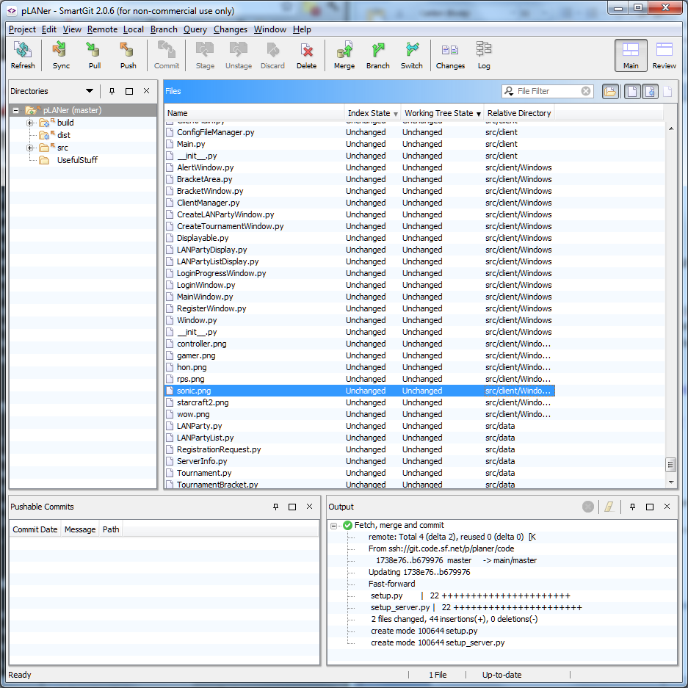
Our GIT repository can be viewed in HTML at the following link:
http://sourceforge.net/p/planer/code/ci/b6799765987033763cdf5693b457ad5b9170f1e7/tree/

Documented Coding Standards
We had a commenting standard as well as a coding standard that we follow in our code.

Coding Standard
We used the following coding standard:
Code Conventions for the Java Programming Language (http://www.oracle.com/technetwork/java/codeconvtoc-136057.html)
However, we modified it slightly to be a better fit for Python. A summary of what we followed is as follows:
Summary:
- Camelcase function names and variable names
  - def myMethod(self)
  - myVariable = 0
- Uppercase alternating class names
  - class ClassName:
- Prefix member variables with an m (Very important for Python)
  - self.mMemberVariable = 0
- Event handler names should be of the form “on<Event-Thrower><Event>”
  - def onButtonClicked(self, widget, data=None)

Comment Style
Our comments for classes and methods all follow the Doxygen style for commenting Python.
The standards can be read at http://www.stack.nl/~dimitri/doxygen/docblocks.html.
In summary, commenting a method looks like the following (taken from DatabaseManager.py):
## Returns the stored phone number for a given username
# @param username The username to get the phone number for
def getPhone(self, username):
…

This commenting style helped us generate documentation to make our project easier to bring new developers up to speed with.

User the Basic Concepts Behind Object Oriented Design
Our program is completely object oriented. For example, all Windows inherit from the Window class, which reduces the amount of redundant code. We also have a Displayable interface that “Displayable” data structures inherit. For example, there is a LANPartyList class and a LANPartyListDisplay class, which displays LANPartyLists. All Displayable objects must have a getDisplay() method, which enables them to be viewed by the MainWindow class. MainWindow is the main window of the application and displays the Displayable in the main region of the window. Also, as shown in the Elaboration and Construction deliverables, the application is highly cohesive and is loosely coupled, meaning there is as much interdependence between the main classes as possible and each class has one purpose. Python does not provide access modifiers, however member variables are kept private and not accessed from outside classes to support good data encapsulation.

10. Bug Tracking System
We used SourceForge’s bug tracker to keep track of important issues and also to list new features to add. We have updated it throughout the semester to show the progress as we wrote pLANer. A screenshot of our Milestone 1 is shown in the bug tracker, as well as a link to it below.
http://sourceforge.net/p/planer/tickets/milestone/1.0/
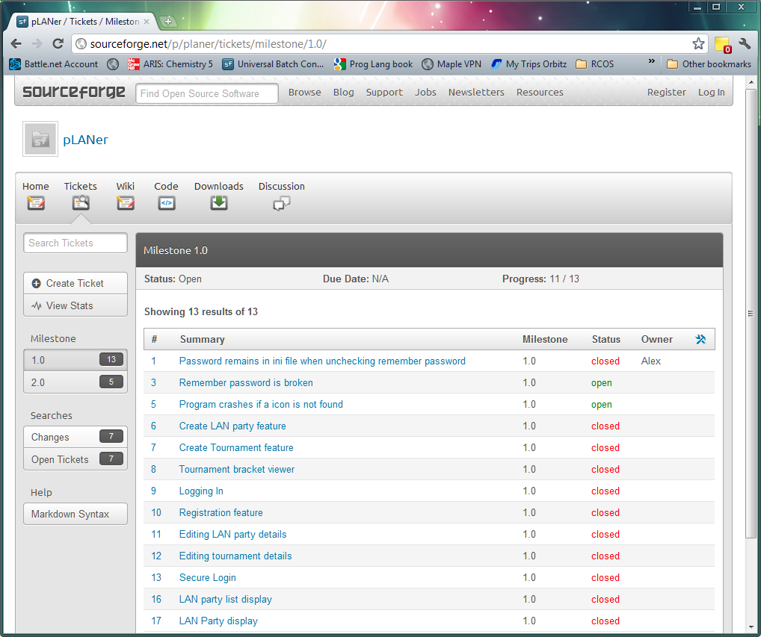

11. Third Party Component or Tool
We used a couple of different open source libraries for creating pLANer. The first one is a networking library called Twisted (http://twistedmatrix.com/trac/), which is written in Python and completely open source. Examples of where we use twisted can be seen in ServerMain.py and ClientMain.py. In the ServerMain class, we override the twisted class LineReceiver, which is a way to implement a custom network protocol. In our case, it was to send and receive LAN party and user data. We also used GTK+ (http://www.gtk.org/) for the GUI. GTK+ is completely open source and is a bare bones framework for creating Windows. Every Window in pLANer uses GTK to display itself. For a simple example, see AlertWindow.py.

12. Design Patterns
We used a couple design patterns in our code including the Factory design pattern. We use this pattern to construct the network protocols that extend LineReceiver class mentioned previously. For example, we have a class called LoginFactory as shown below, which extends to Twisted ClientFactory. This class implements the Factory design pattern by creating a new protocol via the buildProtocol method. The code below was taken from ClientMain.py.
## LoginFactor - A factory that builds the protocol for logging in and maintaining a connection
#
# Provides access to the Main class for registering LAN parties and tournaments.
#
class LoginFactory(ClientFactory):
## Creates a new LoginFactory with the given user information
# @param main The callback to Main
# @param username The username to log in with
# @param password The password to log in with
# @param hashLoaded Whether or not the given password is already hashed
def __init__(self, main, username, password, hashLoaded):
self.main = main
self.username = username
self.password = password
self.hashLoaded = hashLoaded

## Builds the client protocol and prepares it for a login configuration
def buildProtocol(self, addr):
client = Client(self.main)
client.setLoginInfo(self.username, self.password, self.hashLoaded)
self.mClient = client
return client

## …

## Called when the connection to the client failed
# @param reason Why the error occured
def clientConnectionFailed(self, connector, reason):
print "client Connection Failed - goodbye!"
reactor.stop()

## Called when the connection to the Client is lost
# @param reason Why the connection was lost
def clientConnectionLost(self, connector, reason):
print "Client Connection lost - goodbye!"
reactor.stop()

